Sieve Analysis

Particle size distribution
The results of a sieve analysis on a soil sample were:
Sieve size | Mass retained | Mass passing | Summation percentage
(mm) | (g) | (g)
19.0
13.2
9.5
6.7
4.75
2.36
1.18
0.60
0.425
0.300
0.150
0.075
Pan
Total | Σ = | Σ = | Σ =

Plot the particle size distribution curve on the graph below and describe the soil.
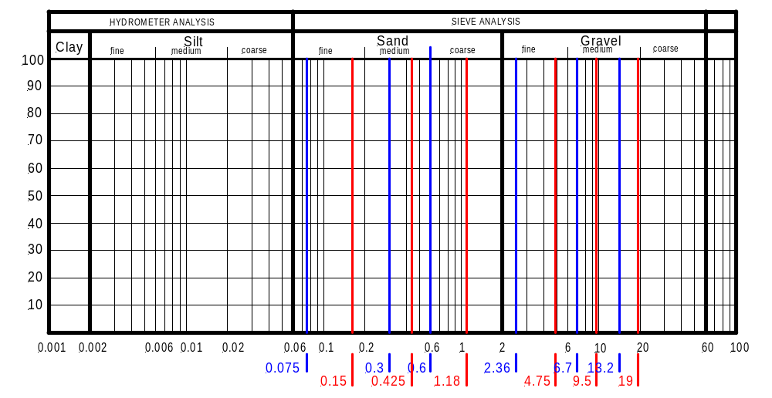

Soil description:

